**Nama : Syifa Amilatun Nadiyah**

**NIM : 12030123120015**

**Mata Kuliah : Analisis dan Desain Sistem**

**Kelas : C**

**Link Chatling :**

<https://share.chatling.ai/s/epnirjzUva8EYU5>

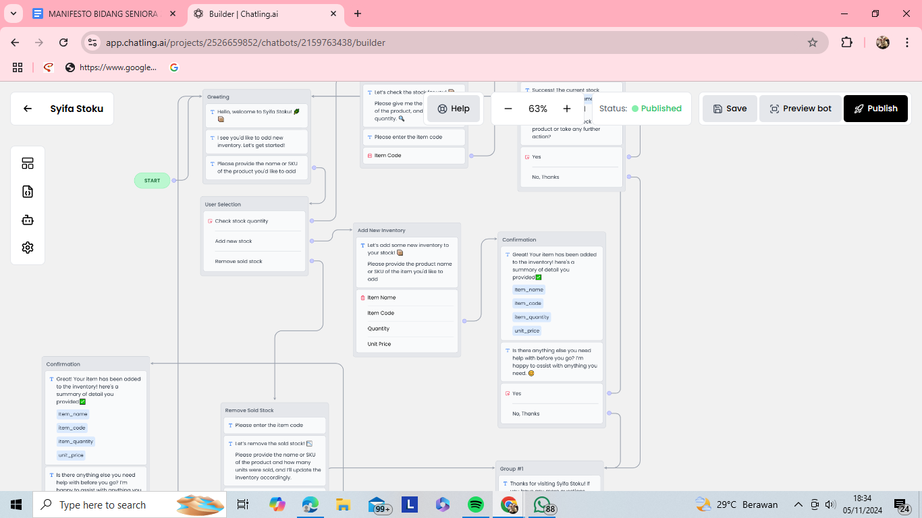

**Preview Percakapan Hasil dari Chatbot**

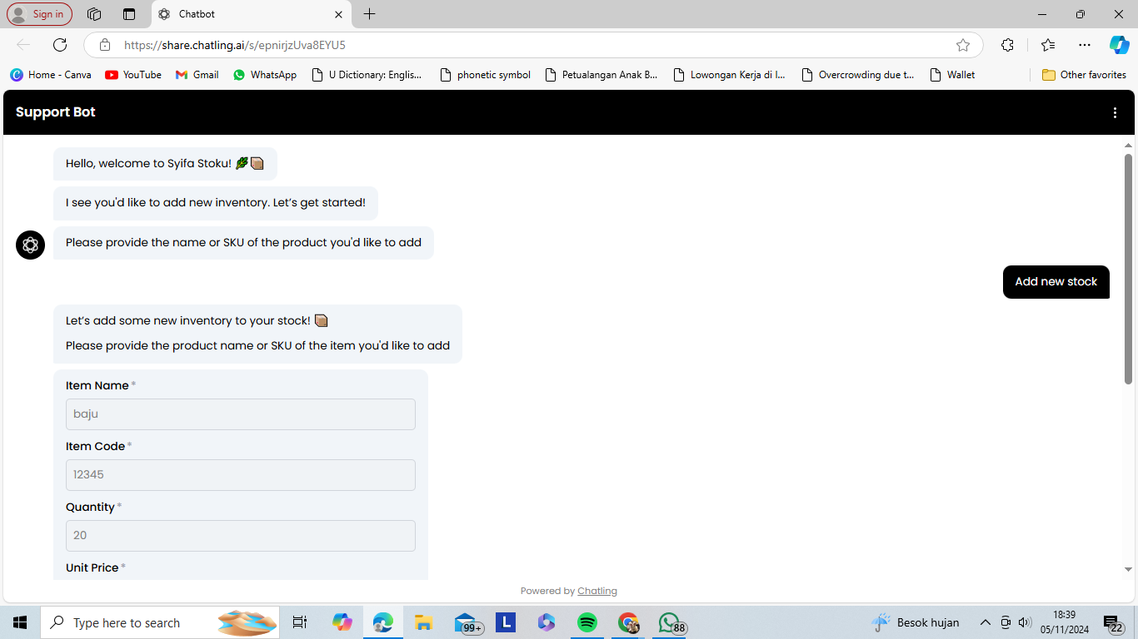

**Copytext Perintah dari ChatGPT**

Buatkan alur workflow chatling sistem persediaan syifa stoku yang berisi chechk stock quanitity, add new stock, dan remove sold stock

**ChatGPT bilang:**

ChatGPT

Berikut adalah **alur workflow Chatling untuk sistem persediaan "Syifa Stoku"** yang mencakup fitur **check stock quantity**, **add new stock**, dan **remove sold stock**. Alur ini mengarahkan pengguna untuk melakukan berbagai tindakan dalam sistem persediaan dengan cara yang ramah, jelas, dan interaktif.

**Syifa Stoku Chatling Workflow**

**1. Welcome & Main Menu**

**Chatbot**:  
"Welcome to **Syifa Stoku**! 📦  
I’m here to help you manage your inventory. What would you like to do today? 😊

1. Check stock quantity 📊
2. Add new stock ➕
3. Remove sold stock 📉  
   Please type the number corresponding to your choice."

**2. User Chooses Option - Check Stock Quantity**

**User**:  
"1" (Check stock quantity)

**Chatbot**:  
"Let’s check the stock! 🧐  
Please provide the **product name** or **SKU** of the item you’d like to check."

**3. User Provides Product Name or SKU**

**User**:  
"I want to check **ABC Widget**."

**Chatbot**:  
"Thanks! Let me check the stock quantity for **ABC Widget**... 🔍"

*System retrieves the stock data.*

**4. Chatbot Responds with Stock Quantity**

**Chatbot**:  
"Success! The current stock quantity for **ABC Widget** is **150 units**. 📊  
Would you like to:

1. Add more stock ➕
2. Remove sold stock 📉
3. Check another product 🔄
4. Exit and end session 👋"

**5. User Chooses Action - Add New Stock**

**User**:  
"1" (Add more stock)

**Chatbot**:  
"Great! How many units of **ABC Widget** would you like to add to the inventory? 🛠️"

**6. User Provides Quantity to Add**

**User**:  
"50 units."

**Chatbot**:  
"Got it! Adding **50 units** of **ABC Widget** to your inventory. ✅  
Would you like to:

1. Check stock quantity again 📊
2. Remove sold stock 📉
3. Add stock to another product ➕
4. Exit and end session 👋"

**7. User Chooses Action - Remove Sold Stock**

**User**:  
"2" (Remove sold stock)

**Chatbot**:  
"Let’s remove the sold stock. 📉  
Please provide the **product name** or **SKU** of the item that was sold, and the number of units sold."

**8. User Provides Product and Sold Quantity**

**User**:  
"I sold **30 units** of **ABC Widget**."

**Chatbot**:  
"Removing **30 units** of **ABC Widget** from the inventory. ✅  
The new stock for **ABC Widget** is now **170 units**. 📦  
Would you like to:

1. Check stock quantity 📊
2. Add more stock ➕
3. Remove sold stock for another product 📉
4. Exit and end session 👋"

**9. User Chooses Option - Exit**

**User**:  
"4" (Exit)

**Chatbot**:  
"Thank you for using **Syifa Stoku**! 🌟  
If you need assistance in the future, feel free to come back anytime. Have a great day! 👋"

**Complete Chatling Workflow Breakdown**

**1. Main Menu Options:**

* **Check stock quantity** 📊
* **Add new stock** ➕
* **Remove sold stock** 📉

**2. Check Stock Quantity Flow**

* User provides **product name** or **SKU**.
* Chatbot retrieves stock and displays quantity.
* User can then choose from options to **add stock**, **remove sold stock**, **check another product**, or **exit**.

**3. Add New Stock Flow**

* User is prompted to enter **quantity to add** for the specified product.
* Stock is updated, and user is given the choice to **check stock quantity**, **remove sold stock**, **add stock to another product**, or **exit**.

**4. Remove Sold Stock Flow**

* User is asked for **product name** or **SKU** and **quantity sold**.
* Stock is updated accordingly, and user is given the choice to **check stock quantity**, **add more stock**, **remove sold stock for another product**, or **exit**.

**Key Features:**

* **Friendly & Interactive**: The chatbot uses emojis and a conversational tone to engage the user.
* **Clear Actions**: After each step (checking stock, adding stock, or removing sold stock), the user is given clear choices on what to do next.
* **Flexible Options**: Users can perform multiple actions (check stock, add stock, remove sold stock) in one session.
* **Exit Option**: At any time, users can exit the workflow and close the session

buatlah kata kata greeting untuk chatling dari perusahaan syifa stoku tanpa kode

**ChatGPT bilang:**

ChatGPT

Tentu! Berikut adalah beberapa contoh kata-kata **greeting** untuk **Syifa Stoku**, perusahaan yang mengelola sistem persediaan dengan menggunakan Chatling. Kata-kata ini dirancang untuk memberikan kesan ramah dan profesional, sambil memudahkan pengguna dalam berinteraksi dengan sistem.

**Contoh Greeting 1:**

Selamat datang di **Syifa Stoku**! 🌿📦  
Kami siap membantu Anda mengelola persediaan dengan lebih mudah dan efisien. Apa yang bisa kami bantu hari ini?

* Cek stok barang
* Tambah stok baru
* Kurangi stok
* Laporan persediaan

**Contoh Greeting 2:**

Halo, selamat datang di **Syifa Stoku**! 👋✨  
Mari kita pastikan persediaan Anda selalu terjaga. Apa yang bisa kami bantu untuk Anda hari ini?

* Lihat status stok barang
* Menambah stok barang
* Mengurangi stok
* Cek laporan persediaan

**Contoh Greeting 3:**

Selamat datang di **Syifa Stoku**! 🌟📊  
Dengan sistem canggih kami, mengelola stok jadi lebih mudah. Pilih apa yang ingin Anda lakukan:

* Cek stok barang
* Tambah atau kurangi stok
* Pemesanan ulang otomatis
* Lihat laporan stok dan analisis

**Contoh Greeting 4:**

Hai, selamat datang di **Syifa Stoku**! 🌿⚡  
Kami di sini untuk membantu Anda menjaga persediaan tetap optimal. Apa yang bisa kami bantu hari ini?

* Cek jumlah stok barang
* Tambah stok baru
* Kurangi stok yang terjual
* Laporan stok dan pergerakannya

**Contoh Greeting 5:**

Selamat datang di **Syifa Stoku**! 💬📈  
Mari kita bantu Anda mengelola stok dengan cara yang lebih cerdas dan mudah. Apa yang ingin Anda lakukan hari ini?

* Lihat jumlah stok
* Tambah stok
* Kurangi stok
* Cek laporan persediaan

**Slogan yang bisa digunakan di akhir greeting:**

* "Menyederhanakan stok, menyukseskan bisnis Anda."
* "Stok Anda terkelola dengan mudah, bersama Syifa Stoku."
* "Solusi cerdas untuk pengelolaan stok yang lebih efisien."

**Tips:**

* **Pilih gaya bahasa yang ramah dan sederhana**, untuk memberikan kesan bahwa penggunaan sistem ini mudah dan tidak membingungkan.
* **Gunakan emoji** untuk menambahkan sentuhan ramah dan menarik bagi pengguna.
* **Tawarkan pilihan langsung** yang bisa membantu pengguna memilih tindakan berikutnya dengan cepat.

Semoga salah satu contoh greeting ini sesuai dengan kebutuhan perusahaan **Syifa Stoku**! Jika ada elemen khusus yang ingin ditambahkan atau disesuaikan, beri tahu saya!

4o mini

**Anda bilang:**

gunakan dalam bahasa inggris

**ChatGPT bilang:**

ChatGPT

Tentu! Berikut adalah beberapa contoh **greeting** dalam bahasa Inggris untuk **Syifa Stoku**, perusahaan yang mengelola sistem persediaan melalui **Chatling**. Kata-kata ini dirancang untuk memberikan kesan yang ramah, efisien, dan mudah dipahami oleh pengguna.

**Example Greeting 1:**

Welcome to **Syifa Stoku**! 🌿📦  
We're here to help you manage your inventory with ease and efficiency. How can we assist you today?

* Check stock levels
* Add new stock
* Reduce stock
* View inventory report

**Example Greeting 2:**

Hello, welcome to **Syifa Stoku**! 👋✨  
Let's keep your inventory in check. How can we assist you today?

* Check stock status
* Add stock
* Remove stock
* View inventory report

**Example Greeting 3:**

Welcome to **Syifa Stoku**! 🌟📊  
With our advanced system, managing your inventory has never been easier. What would you like to do?

* Check stock levels
* Add or reduce stock
* Auto reorder items
* View stock reports and analysis

**Example Greeting 4:**

Hi, welcome to **Syifa Stoku**! 🌿⚡  
We’re here to keep your inventory optimized. How can we help you today?

* Check stock quantity
* Add new stock
* Remove sold stock
* View stock movement and reports

**Example Greeting 5:**

Welcome to **Syifa Stoku**! 💬📈  
Let’s make inventory management smarter and simpler. What would you like to do today?

* Check stock levels
* Add stock
* Reduce stock
* View inventory reports

**Possible Slogans to Include:**

* "Simplifying inventory, empowering your business."
* "Your stock, efficiently managed with **Syifa Stoku**."
* "Smart solutions for seamless inventory management."

**Tips:**

* **Friendly and simple language**: Keep the tone casual and approachable so users feel comfortable using the system.
* **Clear options**: Offering easy-to-understand actions (like checking stock or adding/removing items) can help users quickly decide what they want to do.
* **Emojis**: Adding emojis like 📦, 🌿, and ⚡ makes the greeting feel more friendly and engaging.

These greetings are designed to make users feel welcome and ready to start managing their inventory with Syifa Stoku. Let me know if you want to tweak anything further!

buatkan kata kata reservation for check stock quantity tanpa kode

**ChatGPT bilang:**

ChatGPT

Tentu! Berikut adalah contoh **kata-kata reservation** yang dapat digunakan untuk **check stock quantity** (memeriksa jumlah stok) di sistem **Syifa Stoku**, tanpa menggunakan kode program. Ini adalah percakapan yang lebih alami dan ramah, cocok untuk sistem chatbot yang berbasis teks.

**Reservation Message for Checking Stock Quantity**

**Greeting:**

"Welcome to **Syifa Stoku**! 📦  
I'm here to help you check the stock quantity of any item in your inventory.  
Please provide the name or SKU of the product you'd like to check."

**Step 1: User Inputs Product Name or SKU**

**User**: "I would like to check the stock quantity of the 'ABC Widget'."

**Step 2: Chatbot Response - Stock Quantity Check**

"Thank you for that! Let me check the stock details for **'ABC Widget'**..."

*System processes the request and retrieves data*

"The current stock quantity for **'ABC Widget'** is **150 units**."

**Step 3: Chatbot Follow-up - Action Options**

"Would you like to:

1. Add more stock
2. Reduce stock
3. View a detailed inventory report
4. Check stock for another item"

**User's Response (Example 1)**

**User**: "I want to add more stock."

"How many units of **'ABC Widget'** would you like to add?"

**User's Response (Example 2)**

**User**: "I want to reduce the stock."

"How many units of **'ABC Widget'** would you like to remove?"

**User's Response (Example 3)**

**User**: "Show me the inventory report."

"Here’s your current inventory:

* **'ABC Widget'** – 150 units
* **'XYZ Gadget'** – 80 units
* **'LMN Tool'** – 200 units

Would you like to see more details or download this report?"

**User's Response (Example 4)**

**User**: "Check stock for another item."

"Please provide the name or SKU of the next item you'd like to check."

**Farewell Message (If Finished)**

"Thank you for using **Syifa Stoku**! 🌟  
If you need further assistance, feel free to ask. Have a wonderful day!"

buatkan kata kata add new inventory

**ChatGPT bilang:**

ChatGPT

Tentu! Berikut adalah contoh **kata-kata** untuk **menambah persediaan baru (add new inventory)** yang bisa digunakan dalam sistem **Syifa Stoku**. Kata-kata ini dirancang untuk memberikan instruksi yang jelas dan ramah kepada pengguna yang ingin menambah stok barang ke dalam inventaris mereka.

**Add New Inventory - Reservation Flow**

**Greeting:**

"Welcome to **Syifa Stoku**! 📦  
I can help you add new inventory to your stock. Let’s get started!  
Please provide the name or SKU of the product you'd like to add."

**Step 1: User Inputs Product Name or SKU**

**User**: "I want to add **ABC Widget**."

**Step 2: Chatbot Response - Asking for Quantity**

"Awesome! How many units of **ABC Widget** would you like to add to your inventory?"

**Step 3: User Provides Quantity**

**User**: "I'd like to add 50 units."

**Step 4: Chatbot Confirmation and Update**

"Thank you! You’ve requested to add **50 units** of **ABC Widget**.  
Let me update your inventory for you..."

*System processes the update and adds the stock.*

"Done! Your updated stock of **ABC Widget** is now **150 units**."

**Step 5: Follow-up Actions**

"Would you like to:

1. Add more stock for another product?
2. Reduce stock?
3. View your current inventory report?
4. Check the stock of another product?"

**User's Response (Example 1)**

**User**: "Add more stock."

"Please provide the name or SKU of the next product you'd like to add, along with the quantity."

**User's Response (Example 2)**

**User**: "View inventory report."

"Here's a summary of your current inventory:

* **ABC Widget** – 150 units
* **XYZ Gadget** – 100 units
* **LMN Tool** – 200 units

Would you like to download the full inventory report or check another product?"

**Farewell Message (If Finished)**

"Thank you for using **Syifa Stoku**! 🌟  
If you need further assistance, feel free to ask. Have a wonderful day!"

**Key Features of the Flow:**

* **Clear Instructions**: The chatbot asks for clear details on the product and quantity, making it easy for users to follow.
* **Friendly & Professional Tone**: The conversation is warm and approachable, creating a positive user experience.
* **Instant Updates**: After confirming the quantity, the system immediately processes the addition and confirms the updated stock.
* **Follow-up Options**: After the task is completed, the user is provided with several options to either add more stock, view the inventory, or take further action.

This flow ensures the process of adding new inventory is simple, fast, and user-friendly. Let me know if you would like to modify anything further!